Bank Valuations after the Financial Crisis (2010-2014)

An Econometric Analysis of Deposit Insurance and Performance Drivers

Course: Econometrics (SAFTI Fintech 2026)

Professor: Iordanis KALAITZOGLOU (Jordan)

Submitted by: Group 10

Team Members:

EnQi Sun – 2024361012

Zilu Yang – 2024361085

Zhedong Yin – 2024361067

Qianru Yuan – 2024361047

Ziyan Zeng – 2024361069

Date: May 2, 2026

Word Count:1346

I. Sampling and Data Description

1.1 Data Overview and Summary Statistics
In this report, we study what affected bank profitability and risk after the 2008 financial crisis. We used a random sample of 500 observations. The main variables we looked at are Return on Equity (ROE), Income Diversity, Capital Ratio, and Fragility.
Table 1: Summary Statistics $\text{n}\text{=500}$
Variable | Mean | Median | Std. Deviation | Min | Max
ROE (%) | 6.23 | 7.96 | 36.67 | -458.17 | 475.59
Income Diversity | 44.41 | 39.87 | 49.93 | -205.00 | 765.94
Capital Ratio | 8.81 | 7.92 | 5.50 | -3.30 | 69.66
Fragility | 82.43 | 88.05 | 17.83 | 0.89 | 100.00

The data shows a big difference among banks. ROE has a very large standard deviation (36.67), which means bank returns were very unstable during the post-Lehman recovery. Also, looking at the histograms in the Appendix, none of the variables perfectly follow a normal distribution. For example, ROE has extreme outliers, showing that the banking sector faced severe random shocks.

1.2 Cross-Correlation Analysis
Table 2 shows the correlation between our variables.
Table 2: Cross-Correlation Matrix
 | ROE | Income Diversity | Fragility | Capital Ratio
ROE | 1.000
Income Diversity | -0.182** | 1.000
Fragility | 0.157** | 0.053 | 1.000
Capital Ratio | 0.066 | -0.020 | 0.023 | 1.000
(Note: ** indicates significance at the 5% level)

Economically, ROE and Fragility have a positive correlation (r = 0.157). Because a higher Fragility score means more stable deposits and lower run risk, this shows that banks with traditional deposit funding made more profit. Interestingly, Income Diversity has a negative correlation with ROE (r = −0.182). This implies a "diversification discount"—banks that focused too much on non-interest business actually performed worse.

II. Hypothesis Testing: The Impact of Deposit Insurance

Deposit insurance can stop bank runs, but it might also cause "Moral Hazard" (Diamond and Dybvig, 1983). Because banks feel protected, they might take more risks. We tested this using hypothesis testing.

2.1 Testing Means (Profitability & Risk Levels)
We test whether banks with deposit insurance $\text{DI}\text{=1}$ have different average characteristics compared to the overall population theoretical values.
- Null Hypothesis$\text{(}{\text{H}}_{\text{0}}\text{)}$: ${\text{μ}}_{\text{DI}\text{=1}} \text{=}{ \text{μ}}_{\text{Population}}$
- Alternative Hypothesis$\text{(}{\text{H}}_{\text{1}}\text{)}$: ${\text{μ}}_{\text{DI}\text{=1} }\text{≠}{ \text{μ}}_{\text{Population}}$ (Two-tailed test).

We used a one-sample OLS-based t-test. For ROE, the p-value is 0.7905. Because p >0.05, we fail to reject ${\text{H}}_{\text{0}}$. This means deposit insurance doesn't significantly affect average profit. But for Capital Ratio, the p-value is 0.041, which means there is a significant difference. Among the four variables, only Capital Ratio is significantly different from the population benchmark, while ROE, Income Diversity and Fragility are not.

2.2 Testing Variances (Risk Volatility)
To avoid Type II errors, we also need to look at volatility. Does deposit insurance make bank earnings more volatile? We used an F-test to compare the variance of all four variables between the DI=1 and DI=0 groups.
- Null Hypothesis$\text{(}{\text{H}}_{\text{0}}\text{)}$: ${\text{σ}}_{\text{DI}\text{=1}}^{\text{2}} \text{=} {\text{σ}}_{\text{DI}\text{=0}}^{\text{2}}$
- Alternative Hypothesis$\text{(}{\text{H}}_{\text{1}}\text{)}$: ${\text{σ}}_{\text{DI}\text{=1}}^{\text{2}} \text{≠} {\text{σ}}_{\text{DI}\text{=0}}^{\text{2}}$ (Two-tailed test).

Table 2.2: F-test for Equality of Variances

Variable | F-statistic | p-value (Two-tailed) | Reject ${\text{H}}_{\text{0}}$ (at 5% level)?
ROE | 64.18 | < 0.001 | Yes
Income Diversity | 5.75 | < 0.001 | Yes
Fragility | 2.79 | < 0.001 | Yes
Capital Ratio | 4.44 | < 0.001 | Yes

Conclusion:

As shown in the table, the variance for all four variables is significantly different between the two groups (all p<0.001). Even though deposit insurance does not increase average returns (as we found in Section 2.1), it significantly changes the risk profile of the banks. Especially for ROE, the huge difference in variance provides strong evidence of Moral Hazard: protected banks take more risks, causing highly unstable earnings.

III. Regression Analysis: Drivers of Bank Valuation
To move beyond simple correlation, we estimate a series of Ordinary Least Squares (OLS) regressions with ROE as the dependent variable to examine the relationship between bank characteristics and bank performance while controlling for other factors.

3.1 Model Development
- Model 1 (Risk Base): $\text{ROE}\text{=}{\text{β}}_{\text{0}}\text{+}{\text{β}}_{\text{1}}\text{Fragility}\text{+}{\text{β}}_{\text{2}}\text{CapitalRatio}\text{+}{\text{ϵ}}_{\text{i}}$
- Model 2 (Business Model): Added $\text{IncomeDiversity}$
- Model 3(Fixed Effects): Added controls (Size, NPL, currentRatio, zscore) and Time Fixed Effects (Year Dummies) to control for macro-economic shocks (like the 2011 Euro crisis).
- Model 4 (+StateOwnership): Added the StateOwnership dummy variable (SO=1).

3.2 Regression Results
Table 3: OLS Regression Results (Dependent Variable = ROE)
Independent Variables | Model 1 (Base) | Model 2 (Business) | Model 3 (Fixed Effects) | Model 4  (+StateOwnership)
Constant | -23.867*** | -19.141** | -36.310* | -46.2240**
Fragility | 0.320*** | 0.341*** | 0.288*** | 0.304***
Capital Ratio | 0.415 | 0.387 | 0.403 | 0.446
Income Diversity |  | -0.139*** | -0.073** | -0.074**
NPL (Asset Quality) |  |  | -1.613*** | -1.566***
Size |  |  | 2.093 | 3.57
Current Ratio |  |  | 0.279*** | 0.286***
Z-score |  |  | -0.008 | -0.016
State Ownership (SO) |  |  |  | -8.028**
Time Fixed Effects? | No | No | Yes | Yes
Adjusted R^2 | 0.024 | 0.058 | 0.195 | 0.204
(Note: *** p<0.01, ** p<0.05, * p<0.10)

3.3 Model Selection and Economic Interpretation
Model 4 is the superior model. It achieves the highest adjusted R-squared (0.204), meaning it explains about 20% of the variation in ROE. By including time fixed effects, the model helps control for common year-specific shocks and improves the overall specification.
Based on Model 4, we derive the following economic conclusions:
- Risk and Reward: Are banks rewarded for excessive risk? The data says No. Fragility is highly positive and signifi$\text{cant} \text{(}\text{β} \text{=} \text{0.}\text{304}\text{,} \text{p} \text{<} \text{0.01)}$. Because higher fragility scores mean lower risk (more stable deposit funding), banks that relied on safe, retail deposits outperformed those relying on risky wholesale funding. Furthermore, Capital Ratio is statistically insignificant. Simply hoarding capital did not mechanically translate to higher shareholder returns.
- The Diversification Discount: Income Diversity remains significantly negative $\text{β} \text{=} \text{−0.07}\text{4}\text{,} \text{p} \text{<} \text{0.05}$. For every 1% increase in non-interest income reliance, ROE drops by 0.074%. Post-crisis, banks that stuck to traditional lending models outperformed those trying to be universal financial supermarkets (Laeven and Levine, 2007).
- The Dominance of Asset Quality: The most critical determinant of survival is NPL. A 1% increase in bad loans destroys ROE by an overwhelming 1.566% (p < 0.01). Credit risk management dictates valuation.
- The Penalty of State Ownership: In our final and most rigorous model (Model 4), we introduced the StateOwnership dummy variable alongside Time Fixed Effects. The coefficient is -8.028 and is statistically significant at the 5% level $\text{p} \text{=} \text{0.0106}$. This demonstrates that, even after controlling for global macroeconomic shocks and bank-specific financial health, state-owned banks still severely underperformed their private counterparts by approximately 8.03 percentage points in ROE. This result is consistent with the view that state-owned banks may pursue objectives beyond pure shareholder-value maximization.

IV. Conclusion
Our analysis provides useful insights into the post-Lehman banking sector. First, the evidence suggests that deposit insurance is associated with higher profit volatility in this sample, which is consistent with a moral hazard interpretation, although it does not significantly increase average profitability. Second, our regression results suggest that the market does not reward excessive risk-taking. Banks with more stable retail deposit funding and lower NPLs tend to perform better. Finally, state-owned banks are associated with lower ROE than private banks in our sample. From a policy perspective, supervisors should pay closer attention to asset quality and funding stability rather than relying solely on higher capital ratios.

References
- Brooks, C. (2019) Introductory Econometrics for Finance. 4th edn. Cambridge: Cambridge University Press.
- Diamond, D.W. and Dybvig, P.H. (1983) 'Bank Runs, Deposit Insurance, and Liquidity', Journal of Political Economy, 91(3), pp. 401-419.
- La Porta, R., Lopez-de-Silanes, F. and Shleifer, A. (2002) 'Government Ownership of Banks', The Journal of Finance, 57(1), pp. 265-301.
- Laeven, L. and Levine, R. (2007) 'Is there a diversification discount in financial conglomerates?', Journal of Financial Economics, 85(2), pp. 331-367.

Appendix
Appendix A: Summary Statistics Output from Gretl
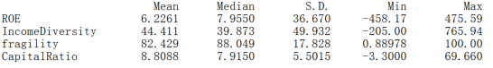
Appendix B: Correlation Matrix Output
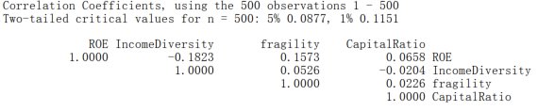Appendix C: Normality Test and Distribution 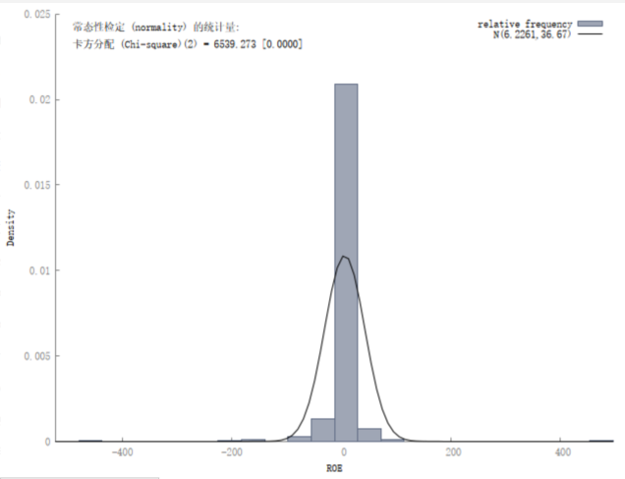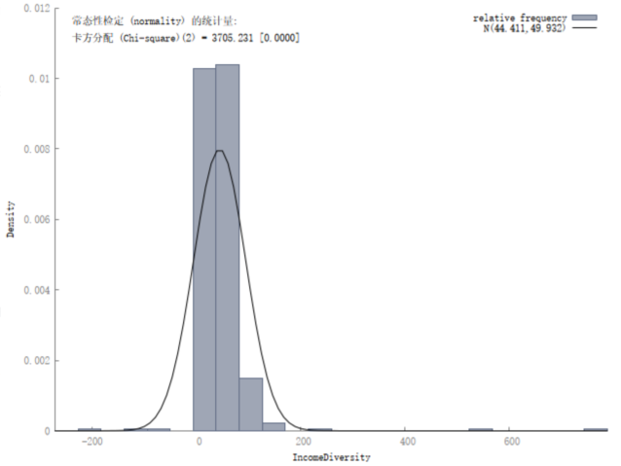
ROE Income Diversity
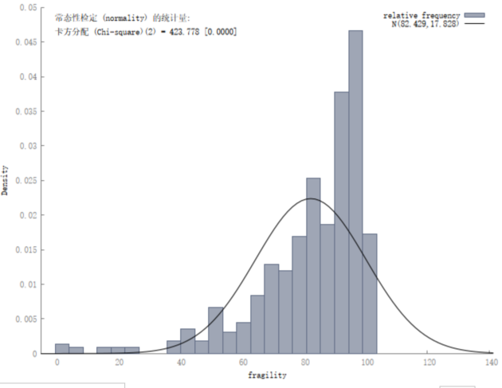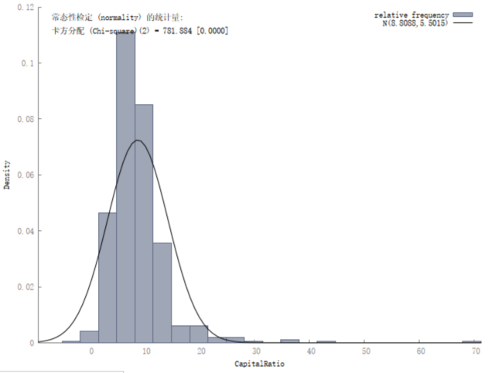
Fragility Capital Ratio
Appendix D: One-Sample T-tests for Deposit Insurance Hypothesis
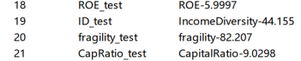
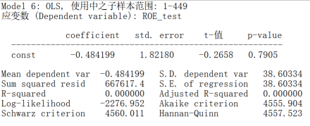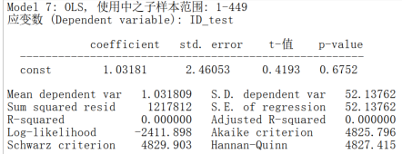
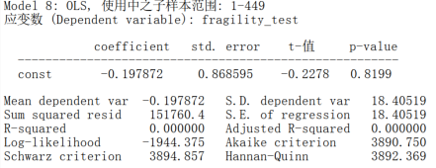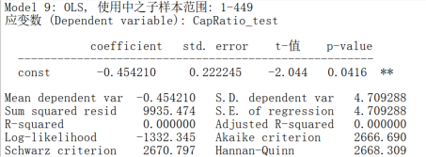
Appendix E: OLS Regression Output - Model 1 (Base)
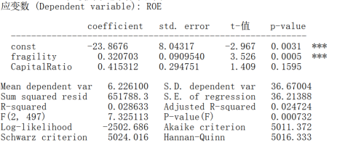
Appendix F: OLS Regression Output - Model 2 (Added Income Diversity)
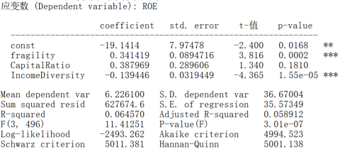
Appendix G: OLS Regression Output - Model 3 (Added Controls & Time Fixed Effects)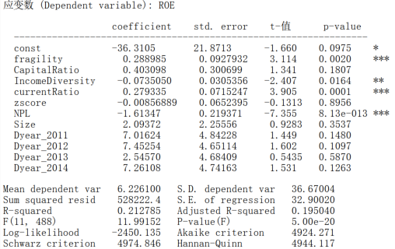
Appendix H: Final OLS Regression Output - Model 4 (Added State Ownership)
